 NARROGIN SENIOR HIGH SCHOOL

ATAR English Year 11

Student: Teacher: Date Due: Wednesday Week 6

Assessment Type: Responding: Short Answer

Weighting: Responding 5%

Task 12

Answer the following questions in short answer responses of 250-300 words per response in the required time frame.

Time allocation: One period.

Conditions: In class.

Mark: / 30

Question Two: 15 marks

Discuss how the construction of Text 2 works to persuade viewers to take a particular action.

Teacher Comment:

Question One: 10 marks

How do language features appeal to the readers’ sense of empathy in Text 1?

Text 1

This is an extract from an editorial entitled ‘Cold Comfort’. It appeared in The Melbourne Daily on December 20, 2014.

Spare a thought this winter for those individuals who will be doing it tough, and sleeping rough, exposed to the elements. As you sit down as a family to a warming Masterchef meal of boeuf bourguignon, or perhaps just a humble roast, count your blessings. And perhaps say a little prayer for Mark.

Mark has been homeless now for 22 months; he has already faced two harsh Melbourne winters this way, doing everything within his power to avoid the nightmare of a frozen night outdoors with only the wind for company. Some nights he has managed to find a bed in a temporary shelter; more often than not he is turned away because such centre are regularly overflowing with desperate individuals just like him who have beaten him to the punch. On nights like these, Mark confides, he often finds it difficult to gather the strength to soldier on. So far he has, but it raises questions: How much longer should he be expected to endure? Which setback will be the straw that breaks the camel’s back?

There is, perhaps, one dim light at the end of the tunnel. The state government this week announced plans to invest another 2.4 million dollars into charitable programs across Victoria, and it warms the heart to think that many more just like him might be spared this winter, might be given the reprieve they reserve. However, unless those funds that have been flagged for release are disseminated quickly and without impediment, it might just be a case of too little too late. At the end of the day, we are talking about human lives; and while we cannot put a price on that, money talks. It won’t be a panacea*, but every little bit counts.

*panacea - a solution or remedy for all difficulties or diseases

Question Two: 10 marks

Discuss how the construction of Text 2 works to persuade viewers to take a particular action.

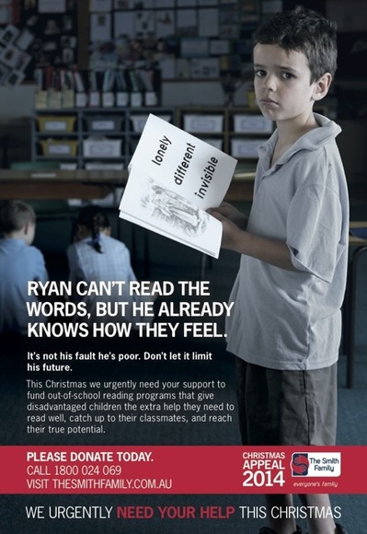
This image forms part of The Smith Family Christmas Appeal of 2014. The Smith Family is a national, independent children's charity helping disadvantaged Australians to get the most out of their education so they can create better futures for themselves.

Question Three: 10 marks

How is the relationship between Billy and May constructed through the narrator’s voice?

The following is an excerpt from the novel, Swallow the Air, by Tara June Winch. Two childhood friends, May and Billy, have just had a huge argument and Billy has threatened to leave town for good.

When I walked up and down Paradise Parade, to Vardy’s house, to the beach, away from the chaos of Aunty and Craig, away from everything we hated, as I walked the black empty streets, I realised Billy was really gone.
Billy and me were like shadows; we could merge into the walls without being noticed. We’d move on the same tides; when we were laughing we couldn’t stop each other, when we were talking neither of us could get a word in, when we were fishing, being sad, or being silent, we were both empty cups. We were rarely angry, we rarely fought, and if we did it was only if I was annoying him, and even then he’d just chase me and kick me up the bum and it’d turn into us laughing together again.
We didn’t talk about Mum or our dads or all the booze and stuff around us, we knew the world in the same way that we knew each other, in the quietness that we shared. It wasn’t in our eyes, or our voices or what we said, it was just there, that understanding, that sameness – it slicked our pores, our skin. It was a feeling that you couldn’t see, or smell or hear or touch, you only knew.
I thought I’d know where he’d be, up the bush, at Bulli Beach, thought I could track him down, thought he’d be where I’d go, the same. But I looked for days, weeks, months. He never came back to Aunty’s, never for clothes or for a feed or to find me. He’d really gone.
And the more he wasn’t there, the more I realised too, we were all gone.

CRITERIA AND CATEGORIES | Marks
Question 1: Your response | /10
Detailed and sophisticated analysis of how language features position the reader; use of appropriate evidence and metalanguage; response is succinct, coherent and clear. | 8 -10
Detailed and sophisticated analysis of how language features position the reader; use of appropriate evidence and metalanguage; response is succinct, coherent and clear with few minor errors. | 6.5 - 7.5
Competent response addressing components of the question supported with some appropriate text-based evidence, with some errors. | 5 - 6
Limited understanding of text with minimal analysis; provides retell with limited reference to the question; underdeveloped expression and a poorly structured response with numerous errors. | 3 - 4.5
Response does not address the question, minimal control of the mechanics of grammar, spelling and punctuation. | 0 – 2.5
Question 2: Your response | /10
Detailed and sophisticated analysis of how Text 2’s construction persuades the reader to take action; use of appropriate evidence and metalanguage; response is succinct, coherent and clear. | 8 -10
Detailed and sophisticated analysis of how Text 2’s construction persuades the reader to take action; use of appropriate evidence and metalanguage; response is succinct, coherent and clear with few minor errors. | 6.5 - 7.5
Competent response addressing components of the question supported with some appropriate text-based evidence, with some errors. | 5 - 6
Limited understanding of text with minimal analysis; provides retell with limited reference to the question; underdeveloped expression and a poorly structured response with numerous errors. | 3 - 4.5
Response does not address the question, minimal control of the mechanics of grammar, spelling and punctuation. | 0 – 2.5
Question 3: Your response | /10
Detailed and sophisticated analysis of how voice constructs the relationship between the characters; use of appropriate evidence and metalanguage; response is succinct, coherent and clear. | 8 -10
Detailed and sophisticated analysis of how voice constructs the relationship between the characters; use of appropriate evidence and metalanguage; response is succinct, coherent and clear with few minor errors. | 6.5 - 7.5
Competent response addressing components of the question supported with some appropriate text-based evidence, with some errors. | 5 - 6
Limited understanding of text with minimal analysis; provides retell with limited reference to the question; underdeveloped expression and a poorly structured response with numerous errors. | 3 - 4.5
Response does not address the question, minimal control of the mechanics of grammar, spelling and punctuation. | 0 – 2.5
 | /30

